**Assignment-UI/UX**

**Design Agency**

**Aim:**

Create a platform to showcase the services of a **Design Agency**.

**Platform Steps:**

1. **Collect Information**: Understand the agency’s services, portfolio, and target audience.
2. **Create Canvas**: Design the layout with sections for **Portfolio**, **Services**, **About Us**, and **Contact**.
3. **Add Elements**: Use high-quality visuals, design mockups, and client testimonials.
4. **Build Features**: Implement **service descriptions**, **interactive portfolio**, and **contact forms**.
5. **Prototyping**: Create an **interactive prototype** to test user navigation and functionality. 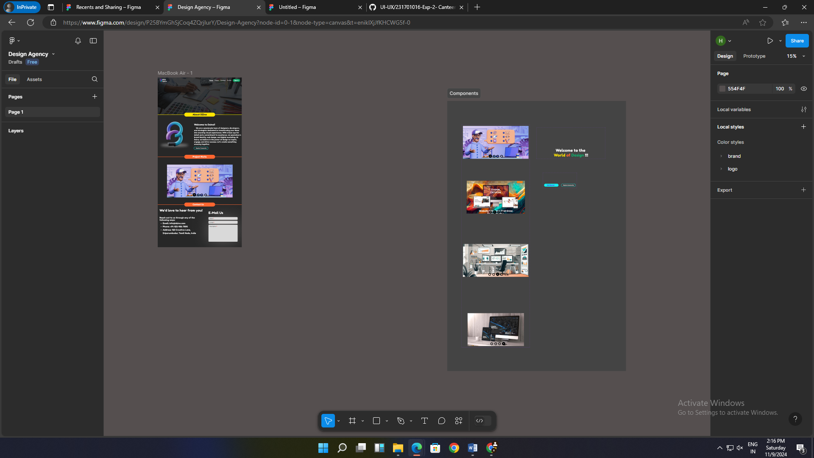

**Result:**

The **Design Agency website** is **created** and **verified**.